Roman Bozeman, William Keen, John Mapes
CSC475 Artificial Intelligence
9/18/2014

Project Proposal

Description:
The project will be to program a learning chess game using AI. The game will be played with one user against the computer.

Scope:
The AI design will be state based. The computer will learn from a growing decision tree. The tree logic will be based on storage and retrieval of chessboard states. The AI process will be composed of:
- Weighted decisions on piece moves.
- Remembering the win percentage resulting from a particular branch.
- The number of games played from a particular branch.
- The difficulty level chosen by the user.

Time Estimate:
Week 1 – Design and implement data storage (decision tree, link lists, etc.)
Week 2 – Design AI components (state retrieval)
Week 3 – Design AI components (weight decisions, user level)
Our AI algorithm will have the following steps:

Week 4 – Incorporate existing GUI chess game for human interface.
Week 5 – Populate database with games
Week 6 – Training game
Week 7 – Adjust AI logic.
Week 8 – Project due.

Data:
The data structure utilized by the game will be decision trees. These trees will be stored as 2-byte pairs per piece representing states of a chessboard. Linked lists will also be stored representing the possible moves of pieces.

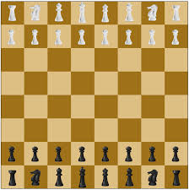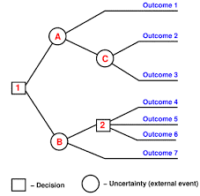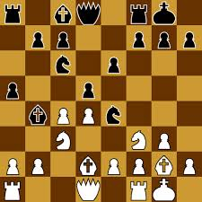

Node data structure:
BoardState: Used to represent the board. The list has two bytes per piece defined as follows:
1st byte is a number from 1 to 64 representing location from top left to bottom right. 2nd byte represents piece assignment.
NumberOfTimesUsed: Number of times this particular node has occurred.
NumberOfTimesWon: Number of times this node has won.
NumberOfTimesDraw: Number of times this node has resulted in draw.
GameHistory: Game number node was last used.
KnownMovesTaken: List of moves taken in the past consisting of links to known nodes.

Global Game Data:
GameCount: Number of games played.
TotalTimesWon: Number of games won.
TotalTimesLost: Number of games lost.
TotalTimesDraw: Number of games resulting in a draw.
UserMove: String user inputs as a move.
UserKingMove: True if player’s King has moved.
ComputerKingMove: True if computer’s King has moved.
HalfMoveCount: Number of moves since a kill or pawn move.
NodesTaken: List of nodes used in current game.
PosibleMoves: List of possible moves of current node.BoardState.

Chess game AI rules:
- Load set-up state.
- Enter user’s move using beginning and ending locations. (Ex. E2:E4)
- Calculate node.BoardState and search known nodes.
- Load known node or initiate new node.
- Calculate PosibleMoves of current node.BoardState.
- Check for “Being in Check”.
- Move to eliminate “Being in Check” and possible instant win.
- See if there is a move the computer can make that will win the game. If there is, take that move.
- Decide move weights based on the following factors.
- Kill value of piece. (King=8, Queen=7, Rook=4, Bishop=4, Knight=3, Pawn=1)
- Node win %.
- Nodes not taken for learning purposes.
- Move piece based on weighted random function.

End Game:
- Update database node path based on win.
- Update global variables.

Exit Program:
Update data file to hard drive.

Data Maintenance:
The data maintenance mode of the program has two main functions. The first is used to grow the node tree by setting relatively high weight on new nodes vs. known nodes. The second function in maintenance mode is tree trimming. This function will be used to delete nodes that have a low number of total times played.

Group Members:
John Mapes
William Keen
Roman Bozeman

